A2599-Eur-Iberia-Figure-Female and Male-Marble-Neolithic-3000-1800 BCE

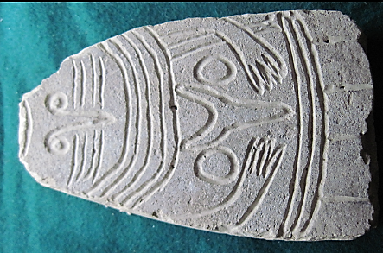

Eur-Iberia-Figure-Marble-Neolithic-3000-1800 BCE

**Case no.: 3**

**Accession Number: A2599**

**Formal Label:** Eur-Iberia-Figure-Marble-Neolithic-3000-1800 BCE

**Display Description:**

**This anthropomorphic incised marble figure has both female and male sexual chacteristics.**

**LC Classification:**

**Date or Time Horizon:**

**Geographical Area:**

**Map:**

**GPS coordinates:**

**Cultural Affiliation:**

**Media:**

**Dimensions:**

**Weight:**

**Condition:**

**Provenance:**

**Discussion:**

**References:**